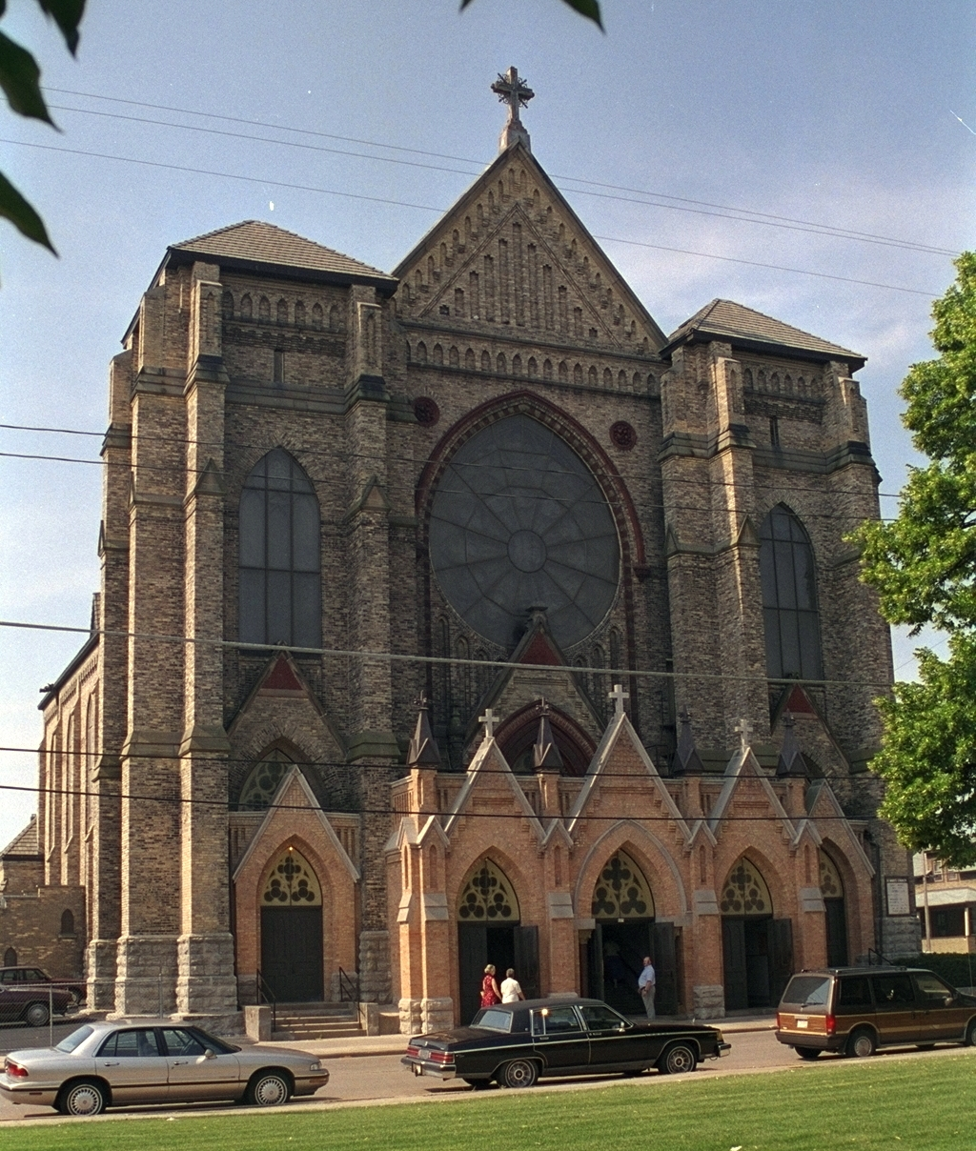

History-
The Founding of St. Mary Parish
Father Florimund Bonduel ministered to the first parish in Oshkosh, St. Peter’s, for a number of years. The congregation grew rapidly, and by 1856, with Oshkosh now a city of some five thousand souls, the Catholic parish could not easily accommodate all the recent arrivals.
That year the German element of the congregation asked for and received permission to start a second parish. Forty founding families were involved in planning and financing the change. They purchased three lots on the northeast corner of Merritt Avenue and Monroe Street for $450, and as was customary at the time, members of the congregation-to-be, built their church largely through their own labor.
The small white frame church was finished and prepared for its dedication in August of 1858. An altar was carefully crafted from boxes; the walls were whitewashed and everything was in readiness when Most Rev. John Martin Henni, Bishop of Milwaukee, came to Oshkosh and, on August 16, 1856, dedicated the new church in honor of the Immaculate Conception of Mary.
Father Francis Fusseder had succeeded to the pastorate of St. Peter’s Church and he was appointed to serve the second parish, St. Mary’s, as well. He was thus the first pastor of St. Mary’s Church. Father Fusseder remained with the two Oshkosh churches until April of the next year when he was succeeded—at both parishes—by Father Thomas Keenan.
As the congregation continued to grow, it became evident that the joint arrangement could not continue indefinitely. So the people of St. Mary’s built a rectory and in June of 1866 were pleased to welcome Father Anthony Leitner as the first pastor to serve the congregation exclusively. It is from this time, incidentally, that the parish records begin. The records previous to that were kept at St. Peter’s.
Father Leitner remained with St. Mary’s for three years. He saw the congregation grow enough so that an addition was needed, and supplied, to the church. He also procured a church bell in 1866. The bell still serves St. Mary’s, although now, silently, as a backup for the electronic bells installed later.
In November of 1869 Father Leitner was transferred, to be succeeded by Father W. F. Boden. That pastorate was the shortest in St. Mary’s history, just seven months. Father Boden was succeeded by Father Julius J. Rhode. Father Rhode’s most significant contribution to the parish was the inauguration of the parish school. Arriving in September, 1870, he set about erecting a school which opened the following year under his supervision and with the assistance of a lay teacher. Shortly after that the Franciscan Sisters of La Crosse, Wisconsin, were called to serve the school. It was in 1900 that the Sisters of St. Agnes began serving the parish as teachers in St. Mary’s School.
Father Rhode left Oshkosh in 1874 and was succeeded by Father John Zawitowski who remained three years. Father Anthanasuim N. Buschle was the next appointee, followed by Father John Jaster. His term was typical of the pastorates in the first twenty-three years of the parish’s history. It had eight pastors in that span, and it seemed that three years was going to be the maximum length of service for each shepherd.
Upon Father Jaster’s departure, Bishop Francis Xavier Krautbauer appointed Father Roman Scholter to the parish, and whether or not it was the Bishop’s intent, the pattern of short-term service was broken; Father Scholter remained at the head of St. Mary’s flock for the next thirty-three years!
By any definition, this pastor and his pastorate constitute a dynamic era in the history of the parish. It is necessary to look at the parish and at the community at the time of Father Scholter’s arrival. The German-born priest took charge on September 17, 1881. He came to a parish which was enjoying a steady growth, although it had-as had Oshkosh as a whole-come through a very difficult time of trial.
The "Great Fire" of 1875 had spared St. Mary’s small frame church, but only by a about one block. It had not, however, spared all the parishioners. Many in this flock suffered the fate that fell upon hundreds of Oshkosh people; they fled the late spring fire in peril of their lives, leaving behind everything they owned. They stood by as the flames claimed block after block, including their own homes and all they possessed.
The years that followed that fire were "building years" in Oshkosh. It was a sign of the times and of the spirit of the people that those who had been burned out renewed their offices, stores, factories, or homes on a scale grander than before. Oshkosh not only rebuilt, it envisioned a city far greater than that which had nearly succumbed to the flames of 1875.
With so many parishioners caught up in that spirit, and with a natural propensity toward that view anyway, it was not strange that, a few years into his pastorate, and when it became obvious that St. Mary’s would have to expand, Father Scholter would think in terms of a "greater scale than Oshkosh has ever known".
He was further encouraged by the man who had sent him to Oshkosh in the first place. Build me a cathedral, said Bishop Krautbauer, in effect. The dynamic growth, the unquenchable spirit of Oshkosh and its indomitable citizenry was recognized by the Bishop of Green Bay. He was, after all, only the second to occupy that See. The diocese itself was only fifteen years old; younger than St. Mary’s Parish. Perhaps the See really belonged in that bustling, booming city on the west shore of Lake Winnebago.
Build me a cathedral, said the Bishop. And Father Scholter and his growing flock set out to do so. The parish building committee formed, conferred, and decided-on January 17, 1886-to appoint a Mr. A. Druiding of Chicago as architect of a new St. Mary Church. Architectural picture?
It was an omen, probably not noticed at that momentous January 17th meeting, that Bishop Krautbauer had died just thirty days before.
A cathedral it would be. Perhaps, as it turned out, not in fact. But certainly a cathedral in the sense of being a house of worship built upon a grand scale and with a purpose of glorifying God through art and architecture, with design and dimension particularly elevating one’s mind to thoughts of prayer. It was to be cathedral-like in the medieval understanding of a cathedral; a house of worship not limited by the precise times, not stifled by constraints to conform to the influences of the day, esthetically, free to express eternal truths to a long succession of generations.
One of the hallmarks of cathedrals, in fact, is that they tend to take interminably long to build. Literally generations build upon the plan, but there seems never to be an end. The plan is so awesome that time and tithe have difficulty keeping up. In this sense, St. Mary’s is also cathedral-like. It has never been completed. Original plans call for twin steeples pointing heavenward, almost twice as high as the 92 feet to the peak of the roof. They were to hold a commanding presence on the Oshkosh skyline.
The death of Bishop Krautbauer did spell an end to the glimmer that Oshkosh would become the See City and St. Mary’s the cathedral. Nonetheless the congregation and Father Scholter moved ahead with the project, and the new Bishop, Frederic Xavier Katzer, laid the cornerstone for the new St. Mary’s on October 3, 1886, just twelve days after being consecrated third Bishop of Green Bay.
For the next several years the work continued at a steady pace. In winter the ice of Lake Winnebago served as a road, marked by fir trees, as teams daily pulled sleds loaded with brick manufactured at High Cliff across the lake to Oshkosh. In two years, the roof was enclosed, and in another two years, at the beginning of 1890, services were first held within the building- in the lower church.
On September 11, 1892, the church was dedicated by the third Bishop of Green Bay to be involved in the huge project. Bishop Katzer had been elevated to the archbishopric of Milwaukee in 1891, and his successor, fourth Bishop of Green Bay, was Bishop Sebastian G. Messmer. Bishop Messmer preached the sermon in English at the dedicatory service. A Father Blum preached the German sermon.
In 1900, on the occasion of the twenty-fifth anniversary of Father Scholter’s ordination to the priesthood, the beautiful high altar which now seems to be an integral part of the design of the church was installed. Not long after, the two side altars which complement the main altar were added. Picture?
Other aspects of the active parish also received Father Scholter’s attention. In 1903 and 1904 the congregation planned and built a new school. It was dedicated on October 2, 1904, by the newest, the fifth Bishop of Green Bay, Joseph J. Fox, who had succeeded Bishop Messmer just three months before.
Father Scholter’s long association with St. Mary’s Parish came to a close on August 15, 1914. He died shortly after saying Mass at the high altar of the magnificent church he had built. It seems particularly fitting that Father Scholter, as the guiding hand in the building of a "cathedral" is buried in the lower church at the spot where he often retired to say his prayers of thanksgiving after mass.
Succeeding to the pastorate of St. Mary’s after Father Scholter’s death was Father Joseph Selbach. His nine years as the leader of the congregation was by no means a rival to the lengthy tenures of his predecessor or of his successor. But the church under his care saw significant developments.
It was Father Selbach who saw to the building of a convent for the sisters who taught St. Mary’s School pupils. And in his time at St. Mary’s, the front steps of the church were enclosed in a design, devised by church member August Pitz, which perfectly complemented the original architecture.
Father Selbach retired in 1923, which, as it happened ushered in the second dynamic era for St. Mary’s, the pastorate of Father William A. Reul. Father Reul served the congregation from 1923 until death in 1953, a term second only to Father Scholter’s thirty-three tenure.
His pastorate was marked by some very important additions to the parish facilities. Father Reul built the recreation center, including the bowling alleys. He added to the school and he built the present rectory.
But more importantly, he guided the parish through some of the hardest of times, and did it in such a way that the church succeeded in maintaining its full vigor despite the economic adversities. When the Depression began, the parish was carrying a debt of some $170,000. That Depression struck Oshkosh, and the working people of St. Mary’s, very hard. Factories closed. The celebrated products of the forest, which first caused Oshkosh to come into being, and which had sustained her through several generations, no longer had a market. Doors and window frames could not find buyers. Nor could the later products of Oshkosh industry. Oshkosh was hard hit by that Depression.
St. Mary’s, under Father Reul, ministered to the needs of the hard-hit parishioners. The parish recreation center was a focal point for activities which were inexpensive and which helped lift the heavy burden from Depression-weary parishioners.
Mostly, however, Father Reul kept the parish financially afloat. An able administrator, he managed to bring the parish through the Depression and on into the era of World War II with a financial outlook which never turned sour. From a Depression-depth debt of $170,000, the pastor was able to announce, in 1947, that the debt had been wiped out.
Father Reul had definitely created a personal imprint upon the parish. He was also popular in the community at large. And the Church also recognized his singular success in leading St. Mary’s Parish. In 1949 Father Reul was elevated by Rome to the rank of domestic prelate with the title of monsignor. Monsignor Reul died on September 28, 1953.
The new pastor sent to guide St. Mary’s arrived in Oshkosh on February 25, 1954, and it was as if Father Scholter’s dream was at least partially fulfilled, for the new pastor was the Most Rev. John B. Grellinger, auxiliary bishop of Green Bay. St. Mary’s did not, of course, take on the dignity of being a cathedral by having a bishop in residence. Nonetheless, on those occasions when Bishop Grellinger celebrated in pontifical array, it seemed, indeed, that the Bishop’s miter complemented the great Gothic arches of the church magnificently, perfectly. It was just as Father Scholter had undoubtedly envisioned the scene.
It was during Bishop Grellinger’s time as head of the congregation that the parish celebrated its centennial. The interior of the upper church was completely redecorated early that year, 1958, as a prelude to the celebration. The school and parish societies held numerous events as the whole parish community became involved in marking the one hundredth anniversary of the formation of the parish.
The actual commemoration was a three-day event in October of 1958, concluding with a mass celebrated by Bishop Stanislaus V. Bona of Green Bay on October 5.
While Bishop Grellinger was pastor of St. Mary’s Church, Pope John XXIII called an Ecumenical Council, and as a Bishop of the Church, the pastor of St. Mary’s was called to Rome to take part in Vatican II. St. Mary’s Parish, then had the unusual distinction of having its pastor taking a role in those deliberations which were to chart the course for the Church for generations to come. A reminder of the very direct relationship St. Mary’s had with the Second Vatican Council are the Stations of the Cross which are highlighted on the west wall of the lower church. These were brought back to St. Mary’s from Rome by Bishop Grellinger.
After eleven years as pastor of St. Mary’s, Bishop Grellinger requested that he be given a smaller parish and he left St. Mary’s in 1965. Father Francis Rose succeeded him and remained with the parish approximately a year.
In 1966 Father William Rickert was appointed to St. Mary Parish. The Church was taking on a new post-Vatican II appearance now and St. Mary’s was a part of that change. Gradually there was more involvement of the laity in the liturgy and in the affairs of the parish. Father Rickert’s tenure with St. Mary’s amounted to twelve years, making his the third longest pastorate, after Father Scholter and Monsignor Reul. In 1978 Father Rickert also asked for a transfer to a smaller parish.
Father David Baeten came to St. Mary Parish to succeed Father Rickert. There were several visible thrusts to Father Baeten’s tenure at St. Mary’s. One was a program of restoration and preservation of the church itself. Its beautiful stained glass required, and received, immediate attention to preserve them for future generations. In it’s 125th year of existence, St. Mary Parish installed a new and impressive roof with the intention that it preserve the church from the elements for the edification of future generations. Other programs implemented were that of modernizing the parish plant, school improvements for saving costs on heating and also improving the learning environment.
Father Larry Seidl was appointed to St. Mary Parish in November of 1988 after Father Baeten transferred to a parish in Neenah. Father Seidl was instrumental in the project of consolidating the Catholic schools in Oshkosh. The schools that were functioning on their own at this time were struggling financially and a committee was formed with the pastors and parishioners from each parish to research the possibility of consolidating-that perhaps they would be more cost efficient if the schools were part of one system. In 1992, the Oshkosh Area Catholic Educational System (OACES) was formed. Sacred Heart School chose to remain on their own. Then with the formation of Unified Catholic Schools of Oshkosh, in 1997, Sacred Heart School joined the system as did Lourdes High School. Catholic education has always remained an important mission of St. Mary Parish.
St. Mary Parish for all its one-hundred and forty two years, has had a spiritual mission which can not and ought not be defined by the physical parish facilities. It is a Christian community and not just a church building. A thrust of St. Mary Parish in the past half-decade has been toward translating the teaching and the spirit of Vatican II and to carry out that teaching.
It is a forward-looking commitment. It is saying that St. Mary’s will be a dynamic force for Christian service for years and generations to come.
But isn’t that the same resolve that brought forty families to pledge themselves to building a new parish back in 1856? And isn’t it the same resolve that Father Scholter called upon when he set about to build a cathedral as his bishop had asked?
On Sunday July 8, 2007 the final liturgy was celebrated by St. Mary’s Parish. On Saturday July 14, 2007, Most Blessed Sacrament Parish officially became a parish with liturgies at St. Mary and St. Peter sites.

